Bijlage 4
EEGLab EMG_fMRI Manual

Based on:

- -Day of the Scan
by Robin Huizing
- -Guide to Artifact Cleaning of the EMG
by Johan van der Meer

Caroline Mattijssen
Marjanne Bom
Bauke Kogelman
Merijn Eskes

modifications by:
Paul Groot
Eric Schat
Nicole van Klink
David Meijer
Tom Konert

Contents
Contents 2
Scanning Procedure 3
Before the scan 3
After the scan 3
Conversion of raw files 5
[obsolete] Cygwin: Transformation of parrec files (MRI) 5
EMG_fMRI as EEGLab plug-in in Matlab 5
Select Dataset 5
Transformation of trc and Log files and fMRI preprocessing 6
EMG artefact correction 7
Correction procedure 7
The New method 7
The Personalised method 7
Create EMG-based regressors 9
Create EMG-based regressors 9
Make Block EMG 12
Make Regressor Fout! Bladwijzer niet gedefinieerd.
Make the regressors 13
Convolve Regressors 14
Make the model for SPM 15
Analysis 16
Model Making: model of the block design 16
Contrasts 17

Scanning Procedure

Before the scan
- Prepare the EMG and bring your laptop.
- Test EMG and batteries
- Check the fMRI room (beamer, mirror, screen)

Attach the EMG wires and check the signal. Replace the wires if the signal is not good enough.

After the scan
All the original data must be copied to the local network in the following directory and subfolders. For each new patient you have to create multiple files and a directory, take e.g. patient 6666 and study Tremor.
Create directories:
- x:\onderzoek\fMRI\Tremor\ruw\6666
- x:\onderzoek\fMRI\Tremor\ruw\6666\parrec
- x:\onderzoek\fMRI\Tremor\ruw\6666\trc

Create files in the directory x:\onderzoek\fMRI\Tremor\ruw\6666:
- channels.txt
- files.txt
- notes.txt

The last thing to do is to copy the data from the MRI computer and EMG computer:
- MRI computer → parrec files → in x:\onderzoek\fMRI\Tremor\ruw\6666\parrec
- EMG computer → trc files → in x:\onderzoek\fMRI\Tremor\ruw\6666\trc

In x:\onderzoek\fMRI\Tremor\ruw there are examples of what the channels.txt, the notes.txt and the files.txt must look like. Below are some screenshots of the files.:

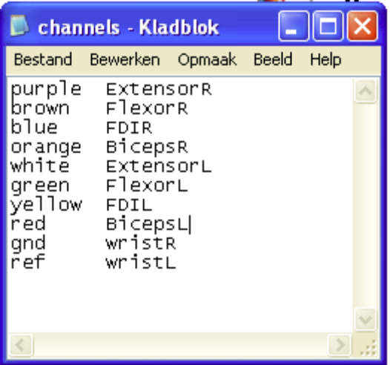
Figuur 1, Example of notes.txt

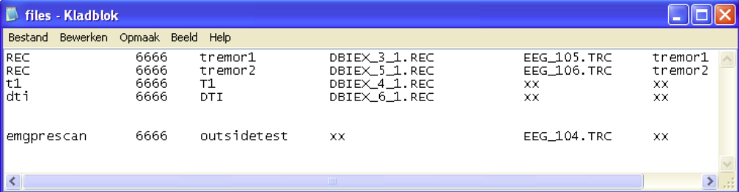
Figuur 2, Example of files.txt

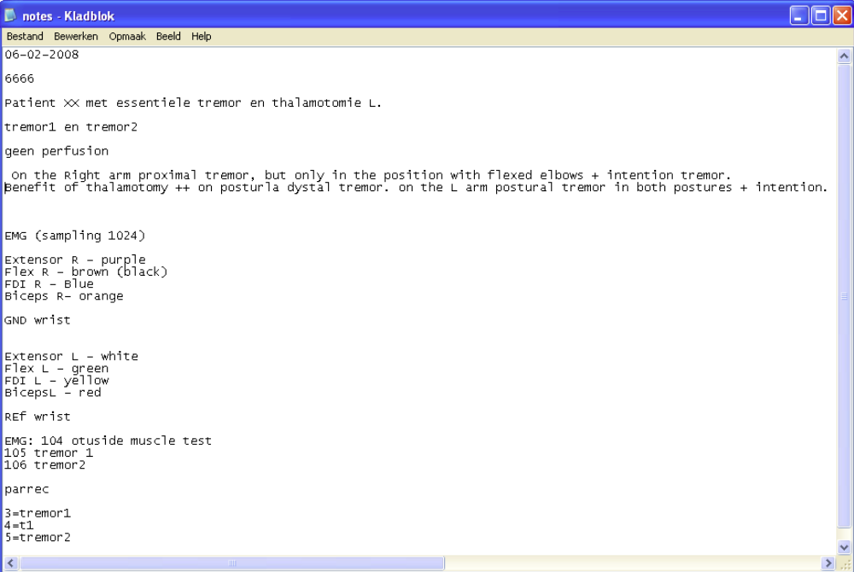
Figuur 3, Example of notes.txt

Conversion of raw files
Before the data can be processed in Matlab the raw files must be converted. This can be done directly after the scanning procedure or on another day.

[obsolete] Cygwin: Transformation of parrec files (MRI)
Conversion of PAR/REC files is now included in the EMG_fMRI GUI by means of calling functions of the r2agui application (http://r2agui.sourceforge.net/).

EMG_fMRI as EEGLab plug-in in Matlab
The EMG data will be managed in Matlab using a graphical user interface (GUI). The GUI can be started by running startemgfmri.m from within matlab. A shortcut to this script can be created on the Matlab shortcut’s toolbar for convenience. The start-up script will add the required directories to the Matlab path and start EEGLab (http://sccn.ucsd.edu/eeglab). The EMG_fMRI GUI will be loaded as plug-in and add a new submenu to the right of EEGLab menu.

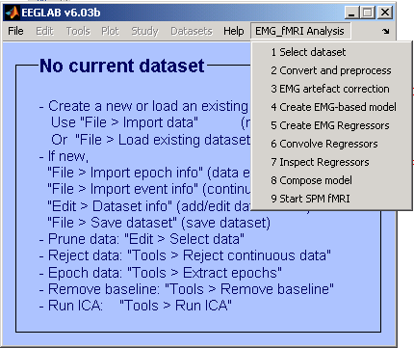

Select Dataset
The following steps are necessary for all that follows! If Matlab is closed and restarted again, this step needs to be done! So keep in mind that every time you are going to work with the EMG_fMRI plug-in execute the following:
- In EEGLab
- Click on the menu ‘EMG_fMRI analysis’
- Click on ‘Select Dataset’

A new popup window will occur. In this screen the study (Tremor) and patient identifier must be filled in and the study directory must be chosen (x:\Onderzoek\fMRI\Tremor). Furthermore the protocols must be filled in, e.g. tremor1 & tremor2. Up to 5 protocols can be defined. (Just leave unused protocol boxes empty.)

Transformation of trc and Log files and fMRI preprocessing
Make sure the previous step ‘Select Dataset’ has been done! Then the following steps will transform trc files to emg.mat files in all the folders and create two extra files inside the EMG folder (only if an emg measurement outside the scanner was done):

- In EEGLab
- Click on the menu ‘EMG_fMRI analysis’
- Click on the menu ‘Convert and pre-process’

The pop up that will appear has three conversion options and one pre-processing option.
- Convert EMG Data → starts batch_emg_to_mat → transforms trc into emg.mat files
- Convert Log Data → starts batch_log_to_mat → transforms log files to block.mat and event.mat (if there are no log files, this script still has to be run for creating block.mat).
- Convert MRI Data → starts batch_parrec_to_analyze→ transforms PAR/REC into analyze (hdr/img) files
- Preprocess fMRI Data → starts SPM5 and batch_fmri_preprocessing → this will execute a bunch of spatial preprocessing methods in SPM. (If you choose this option, eeglab will be closed and preprocessing of the fMRI data will be done in SPM fMRI. After SPM fMRI is done you need to restart EEGLab with the following command in Matlab: “eeglab redraw”.( The command window is the place where you can execute commands.) These steps require time to complete:
  - Slice timing correction
  - Reorienting image
  - Coregistration
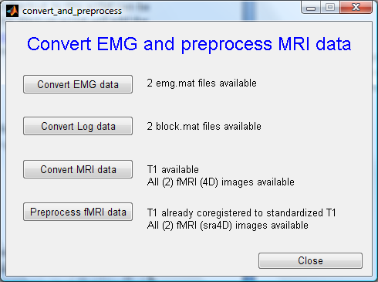
  - Normalization
  - Smoothing

The pre-processing of EMG data will take approximately 10 minutes, the pre-processing of log data will take less then 20 seconds and pre-processing of fMRI data will take approximately 90 to 120 minutes.

EMG artefact correction
The EMG signal is full of artefacts which basically consists of two major components:
- From moving wires in the 3Tesla field. The greater the velocity of the wires, the bigger the artefact. This one is the easiest to remove by simply using a filter.
- From the EPI sequence used by the scanner to record images. This artefact originates from the fast-changing 10 mTesla field. Although it is a relatively small field, the artefact is huge, because of the fast changes. This artefact consists of two types:
  - Volume artefact, once in every TR (e.g. 2.9 secs)
  - Slice artefact, once every slice (~60msec)

Correction procedure
The data will be corrected in EEGLab, using the EMG_fMRI plug-in. This plug-in uses EEGLab functions and the FMRIB plug-in developed by the University of Oxford Centre. It also uses some Matlab scripts created by Johan van der Meer.
- In EEGLab
- Click on the menu ‘EMG_fMRI analysis’
- Click on ‘EMG artefact correction’

After selecting the desired protocol a file selection dialog will be shown to select the raw EMG file. This will normally be the emg.mat file. After loading the selected file, the data will be made bipolair (only required for channels 5-12). Next, a dialog window will appear that has two choices, Personalised and New. These will be described below.

The New method
If the new method is selected, a fully automated artefact removal script (emg_corr) will be run. This is the script J.N. van der Meer has made to remove the artefacts. The script will perform the following steps:

- load emg, make bipolar, add muscle names, add slice triggers (using channel 1-4 with max value) and save as emg_added_slicetriggers.mat
- remove EMG before first and after last volume and save as emg_added_slicetriggers_revised
- apply high-pass, call do_new_slice_timing3 (using channel 1-4 with max value) and save as state_after_slice_timing.mat
- call do_volume_correction and save as state_after_volume_correction.mat
- call do_pca and save as state_after_pca.mat
- apply high pass, call do_anc, apply low pass, insert burst segment events, remove outside measurement data, remove slice events, add model events and save as emg_corrected.mat

The Personalised method
Using the personalised method most steps can be manually executed and values can be manually assigned. The EMG data is processed per protocol. The processed EMG signal can be inspected and saved at any point. It is also possible to load, edit and save a profile containing parameter values. With the inspect data button two plots will show up. One plot showing the power spectrum and one plot showing the EMG data. The save button saves the EMG data into the ../protocol/emg directory (e.g. ../tremor1/emg/). The filename will be: emg_oude_methode_xxx_year.month.day.time. The following functions are available:
- Choose Channel: will make the data bipolar using emg_make_bipolar. After this, a plot will be displayed with the bipolar EMG data. Then a popup will be displayed where a channel can be chosen. Look at the channels and choose the one with the greatest artefact and click on the bullet consistent with the channel and press OK. This channel will be used for the placing of the slice triggers. To have a good view fill in a value of 20000 and go to e.g. slice 80.
- Add Slice-triggers: runs the emg_add_slicetriggers script which add slice triggers to the data.
- Apply Highpass filter: will apply a highpass filter on the data with the desired cutoff frequency. The standard values is 25.
- Remove slice artifact: will start FMRIB Tools → FASTR. This will remove slice artifacts. The standard values are 0, 10, 10 and 0.07. Use dots, not commas! This will take ~10 min.
- Remove volume artifact: will start FMRIB Tools → FASTR. This will remove volume artifacts. The standard values are 0, 10, 10 and 0.03. Use dots not commas! This will take ~10 min.
- Apply freq. bandpass filter: runs emg_filter_bandpass. The standard values are 20 and 250.
- Optional lowpass filter: is not needed, and does not have standard values.
- RUN ALL. This will execute all of the above steps with the current profile.
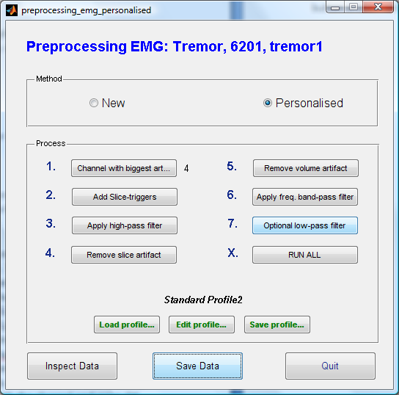
Now it is done and the data can be inspected, if it is OK, save the data using the save data button and do not forget to save your profile if you want to use the settings again.

Remove peak artefacts
In 2010 students of the Universeit Twente were asked to write a new method for artefact correction. The main target were the peaks in the beginning and the end of the activation periods seen on the EMG corrected signal. An activation period is defined as the time from the initiation till the termination of an action which is done by the patient during a fMRI-EMG co-registration. Removing these peaks would make the EMG data more ‘clean’ for analysis. See also ‘Verbetering van analysetechnieken van gecombineerde EMG-fMRI techniek voor het bepalen van de doelstructuur voor diepe hersenelektroden bij essentiële tremor’ written by:
- Eric Schat (e.schat@student.utwente.nl)
- Nicole van Klink (n.e.c.vanklink@student.utwente.nl)
- David Meijer (d.meijer-1@student.utwente.nl)
- Tom Konert (t.konert@student.utwente.nl)
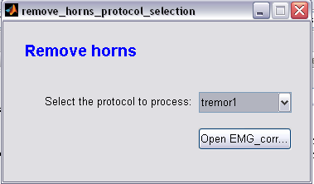
Their method for artefact correction is based on targeting the peaks and giving 1000 samples left and right from the peaks the value of the envelope-mode of the activation period after a Hilbert transformation.
To remove the artefacts in the EMG corrected signal, in EEGLab do the following:
-In EEGLab
-Click on the menu ‘EMG_fMRI Analysis’
-Click on the ‘Remove Artefacts’
A window will pop up with the following option:
- Open EMG_corrected

Open EMG_corrected (remove artefacts)
- Choose the EMG corrected data
- An EMG signal shows up which consists of the sum of the signal of all eight muscles together
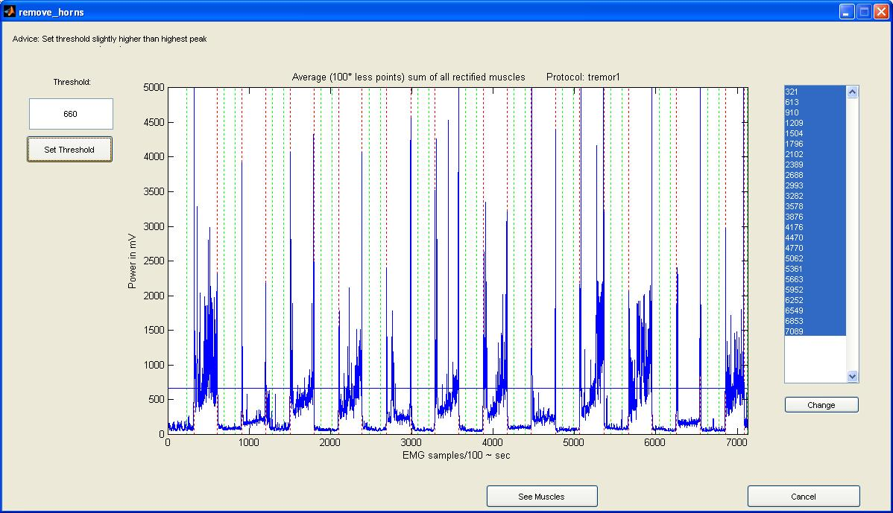

- Determine the threshold so that the peaks at the beginning and the end of each activation period are included. The red vertical lines show the beginning and end of an activation period. Advice: Set threshold slightly higher than the highest peak in a rest period.
- If you’re satisfied with the threshold click ‘Set x-values’. All the x-values of the beginning and end of each activation period will show up in a list.
- Click a value in the list and then click the ‘change’ button if you want to change a x-value. After that click the place in the EMG signal that you want as your new x-value and press ‘Enter’. After this your selected x-value will change in the list.
- If you’re satisfied click ‘See muscles’ to view the beginning and end of an activation period per muscle.

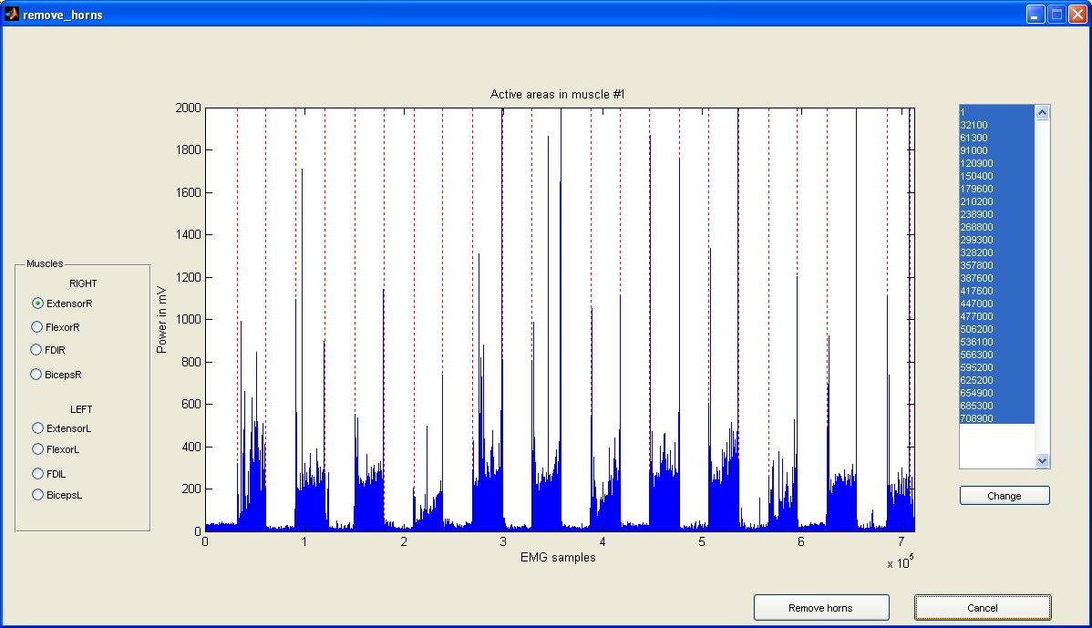
- You will notice a sidebar with all the muscles named. You can go through each muscle
and you can change x-values per muscle. The changes you make per muscle won’t affect the others muscles. If you want to change x-values repeat the same actions as you did in the fifth step.
- If you’ve seen all the muscles and you’re satisfied click ‘remove horns’.
- After this the peaks are removed and you can see what is removed by the red color in the signal.
- To remove the horns in the middle of an activation period click ‘Add’, then click on the peak you want to remove and press ‘Enter’. You will see immediately what you removed.

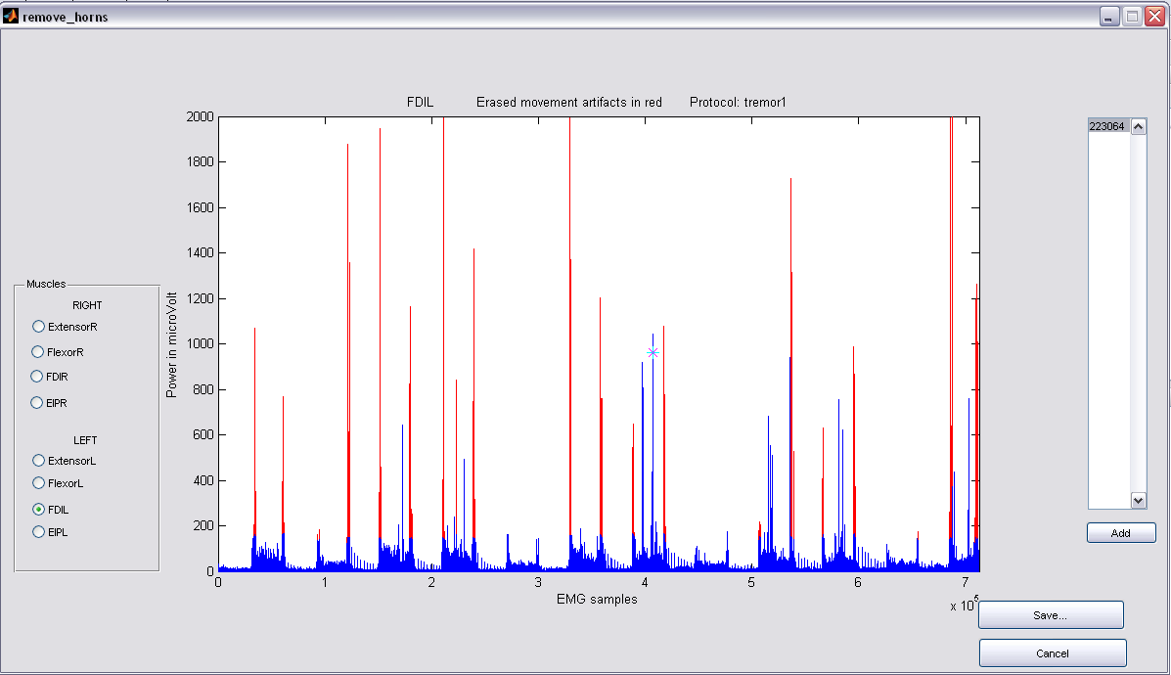

- If you’re done, click ‘Save..’ and your data will be saved as ‘emg_corrected2.m’

Create EMG-based model
In 2009 students of the Universiteit Twente were asked to write a new block design used in SPM. This block design is not based on the protocol information, but on EMG measurements. So it respresents the real activity of the patiënt. See also “Bepaling van de doelstructuur voor plaatsing van diepe hersenelektroden bij essentiële tremor met gecombineerde EMG-fMRI techniek” written by:
• Caroline Mattijssen (c.k.h.m.mattijssen@student.utwente.nl)
• Marjanne Bom (m.j.bom@student.utwente.nl)
• Merijn Eskes (m.eskes@student.utwente.nl)
• Bauke Kogelman (bauke@kogelman.net)

To make a block design based on the EMG, in EEGLab do the following:
- In EEGLab
- Click on the menu ‘EMG_fMRI Analysis’
- Click on ‘Create EMG-based conditions’

A window will pop up with two options:
• Make Block EMG
• Make regressor

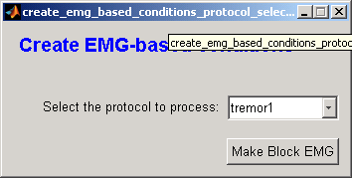
Make Block EMG
• Choose the filtered EMG data
• Determine the threshold so that the activation of the muscles is included

• Repeat the previous step 7 times (8 muscles). The thresholds will be saved in a separate file: thresholds.txt.
• Choose a right muscle (1-4) and a left one (5-8) in which you can recognize the tasks best. The model will be saved as ‘block_emg.mat’ in the map ‘regressor’.
• After you have done this, you have two options: close all windows by hand or close all windows including EEGLab. You can restart EEGLab by the following command in the command window: eeglab redraw

Make the regressors
If you like to make the block design based on the artefact free EMG data, you will have to do the following:
- In EEGLab
- Click on the submenu ‘EMG_fMRI Analysis’
- Click on ‘Create Regressors’

This step is optional. A popup window will appear in which you can enter values for a frequency band filter. If you choose 1-250 Hz the whole EMG is used for the regressor, if you choose e.g. 3-7 Hz only the EMG with frequencies around the tremor frequency will be used as regressor (for essential tremor). Standard is 3-7 Hz. In the popup window also 5 buttons are visible, which represents the protocol which you entered at the first step of the EMG-fMRI tool. If you press a button a new popup window will appear in which you can select the EMG data This EMG will be used for the regressor and the bandpass filter of the previous step will be applied to this EMG. After that the EMG is loaded in Matlab (duration: + 1 minute) and the bandpass filter is applied, a new window will popup. In this window you can select the muscles you like to use for your new regressor by clicking on the checkboxes. You can also inspect the EMG-data with the inspect button. You can only select two muscles, but for one model you mostly need one muscle. What you will see in this window is a picture of the values of the regressors in the freqreg matrix, that is the matrix after the bandpass filter. So if you had chosen 3-7 Hz, you see the EMG in the tremor area. You can view the different muscles by clicking on the next and previous buttons. After selecting the muscles, you press the ‘Ready & Make regressors’ button. Then you will be asked to select a .mat file to orthogonalize with, this can be the block_emg.mat (created with the previous method), but also the block.mat (the other one). You can find these files in the regressor directory. The new EMG regressors will be made and window with several plots will popup:
• bandpass filtered frequency regressors left and right
• an orthoganalized version of the bandpass filtered frequency regressors left and right
• EMG-based block design (4 conditions) and chipped version (4 conditions)
• Orthogonalized EMG regressors split by condition (4 conditions for left and right)

After the last window appeared you can inspect the data and close the windows. After that you can process the other protocols.
The following regressors will be made:
• frequency regressor: The EMG regressor with the bandpassfilter (e.g. 3-7 Hz) : freqreg_{L,R}.txt
• orthogonalized frequency regressor: ortho_freqreg_{L,R}.txt
• orthogonalized regressor; The above regressor orthogonalized with the normal model (block or block_emg), and divided by it’s standard deviation. Separate files will be created for all 4 conditions (links strekken, rechts strekken, beide strekken, rust) for both left and right selected muscles: ortho_emg_{L,R}_{ls,rs,bs,r}.txt

Convolved version can be created in one of the final steps of the GUI. Orthogonalizing will be done with the selected Block model: block.mat or block_emg.mat. The ‘frequency regressor’ means that this is the EMG with the bandpass filter.

Convolve Regressors
Use this menu item to apply one of the predefined hemodynamic convolution functions to the previously created regressors.

Inspect Regressors
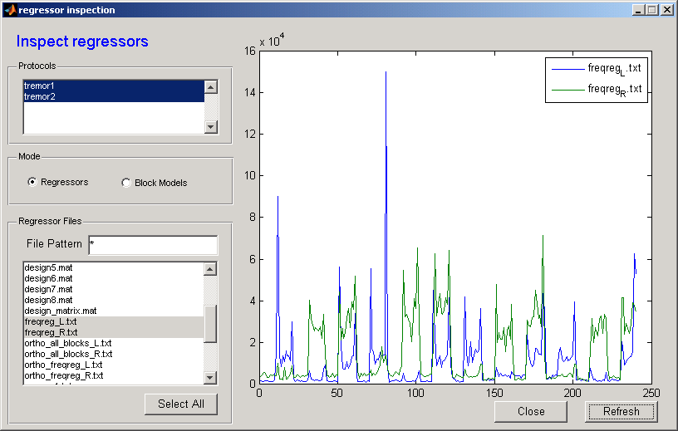

Make the model for SPM
After you made the new regressors for the protocols which you have processed in the previous step, you can make a model for SPM fMRI by combining several regressors. This step is only needed when you want to create a model with several regressors, e.g. a model that contains the ‘normal EMG-regressor’ but also included additional regressors such as movement parameters. To make the new model for SPM you will have to do the following:
- In EEGLab
- Click on the menu ‘EMG_fMRI Analysis’
- Click on ‘Compose Model’

After that, a window will popup which allow you to select the protocols and existing regressors. You can look for regressors which show tremor. Optional you can select the rp_a4D (realignment) parameters. When the parameters are ‘high’ (above 0.5) but not block like you can select them, but if they are low it is not needed. When they are ‘low’ and ‘block like’ you can select them, but if they are ‘high’ and block like you have a problem. There is some discussion about what to do then. (if you are not sure if they are block like, you can also try and make 2 models, one with and one without the movement parameters and compare the design orthogonalities. If they are mostly independent of task, you can choose for the model with the parameters)
After you‘ve selected the regressors, the new model will be made if you press the ‘Make model’ button. A dialog will ask you for a filename and it is also possible to change the folder, but the default folder is recommended to use.

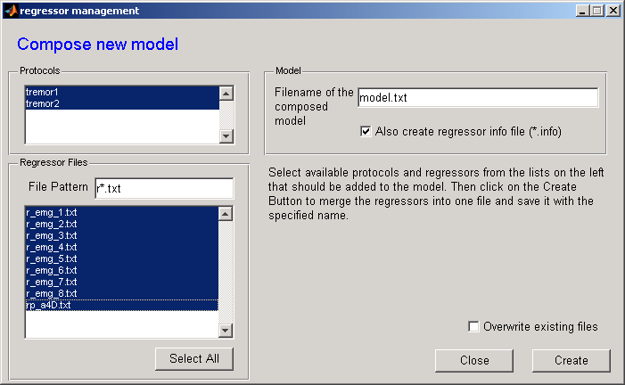

Analysis

Model Making: model of the block design
The following steps will be done manually in SPM and will quit EEGLab.
- In EEGLab
- Click on the menu ‘tools’
- Click on the submenu ‘Start SPM fMRI’
- A confirmation popup will occur, click OK.

The first thing to do now is to create two directories in \pp\6666\protocol\ (protocol is e.g. tremor1). Create a results folder:
- x:\onderzoek\fMRI\Tremor\pp\6666\tremor1\results

Create a subfolder with the name of your model in the results folder:
- x:\onderzoek\fMRI\Tremor\pp\6666\tremor1\results\name of your model

In SPM do the following:
- specify first level
- fMRI model specification
- directory
specify files: …\pp\6666\tremor1\results\name of your model

- timing parameters
  - units for design = seconds
  - interscan interval = 2.8889
  - microtime resolution = 16
  - microtime onset = 1 (this depends on the slice timing)
- data and design
- new subject\session
  - scans
  - specify files (which files must be analysed)
    - \pp\6666\tremor1\fmri\swa4D (wrapped)
    - Or \pp\6666\tremor1\fmri\sra4D (not-wrapped)
  - If you type sra.* (ore swa) and in the place beneath 1:1000 you are sure you can select all sra-files. For selecting you can use Control A.
- Multiple conditions
  - Specify file = x:\Onderzoek\fMRI\Tremor\pp\6666\tremor1\regressor\block.mat
    - or block_emg.mat, block_emg_without_rest.mat or block_without_rest.mat (this are the regressors made with the UT method, or the other method)
- Multiple regressors
  - Specify file = x:\Onderzoek\fMRI\Tremor\pp\6666\tremor1\regressor\name of the model you’ve made. This is for example the convolved orthogonolized frequency regressor of the Extensor Left together with the movement parameters.
- Save as Job.mat (in the pp\6666\tremor1\results\name of your model)
- Run
  - This will get the SPM.mat file, to check the file
    - Review
    - Select spm.mat
    - Click design
    - Design matrix and/or Design orthogonality
- Estimate
  - This takes approximately 10 min.
  - Model estimation
    - Specify files = x:\Onderzoek\fMRI\Tremor\pp\6666\tremor1\name of your model\SPM.mat
  - Method = classical
  - Run

Contrasts
To look at the activation of the brain at different conditions, use contrasts in SPM:

- Results
  - Select SPM.mat in the directory:
    - X:\Onderzoek\fMRI\Tremor\pp\6666\tremor1\name of your model\SPM.mat
- Define the contrasts you are interested in
  - Mask with other contrasts = ‘NO’
  - Name of your contrast
  - None
  - Threshold = 0.001
  - Extend threshold = 0
    - Overlays
      - Sections = select the t1 (you can find this in pp/patient’s number
    - Goto global maxima (ore another place you’re interested in)
  - You can save figures as e.g. jpg-pictures.

